Seth Leung Woo-Gabriel
Dr. Samuel Rodriguez
Senior Project Design
3/3/2024

This week I worked on getting the chart to work and I was successful in having a chart shown on the stock market page. I watched many videos to get it to work. As of right now I have to intraday time, but I can always change it too weekly and daily. I did run into some issues as if I do the time series to daily it says that it is premium endpoints meaning I will have to subscribe to where I got my free stock API from, so it won’t be free anymore as I will have to pay for it. I am looking into getting a free stock market API for free and offers daily times as well. I also had not been feeling too good this past week for about a day or two so that set me back just a bit, but I am working more now. The next step is to get the stock market pattern recognition going now. I have a screenshot of the chart and how it looks of Amazon Stock.
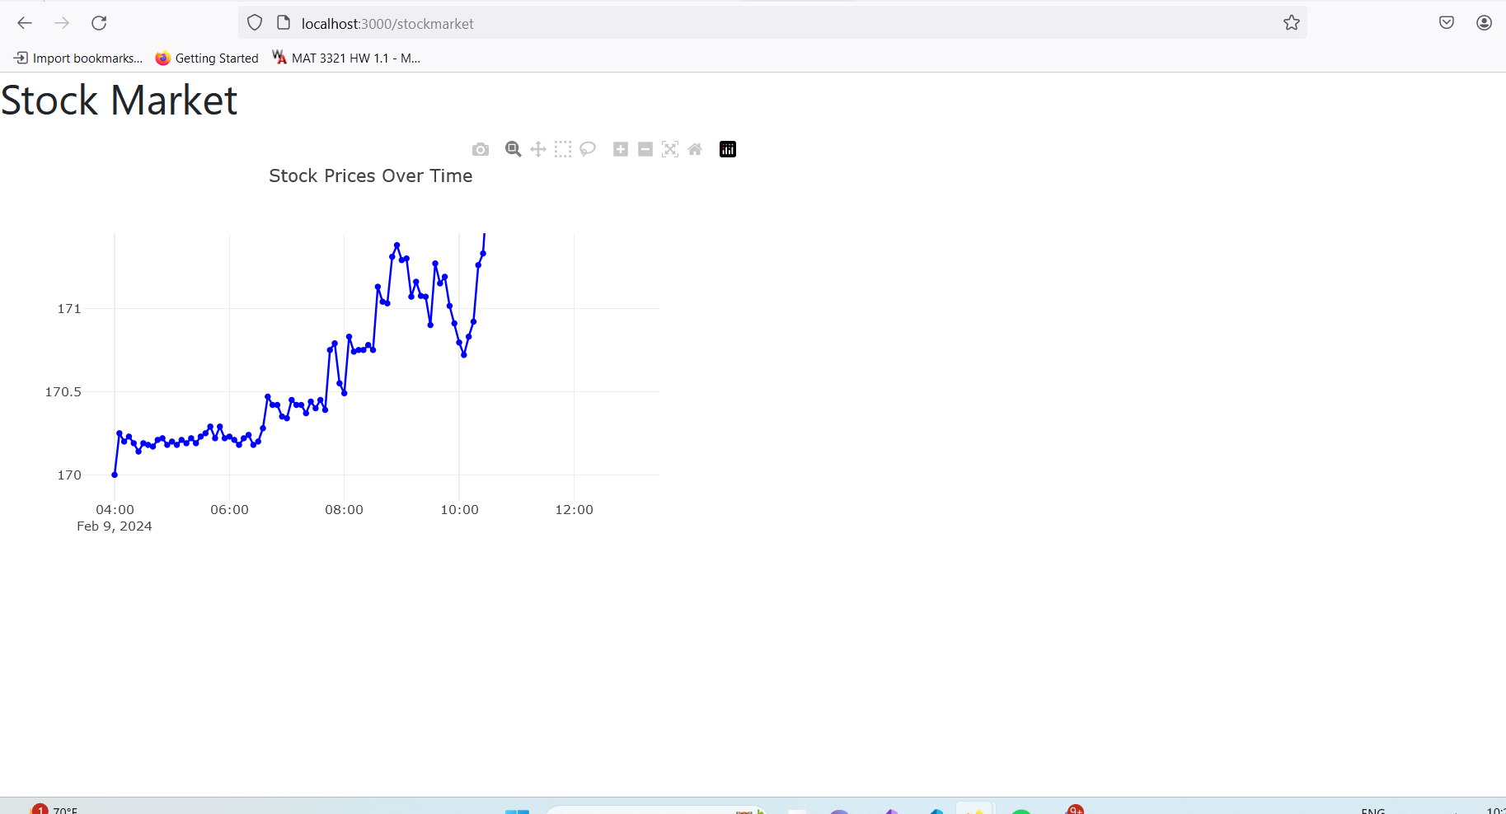

Still more work to do on it but I have to display this for intraday time.

